Project Initialization and Planning Phase

Date | 15 Nov 2024
Team ID | 739938
Project Name | AI Enabled Candidate Resume Screening
Maximum Marks | 3 Marks

Define Problem Statements :

The AI-Enabled Resume Screening project aims to automate and enhance the process of screening resumes for job applications .By leveraging artificial intelligence and natural language processing techniques, the project enables recruiters or hiring managers to efficiently analyse and evaluate resumes to identify suitable candidates for further consideration

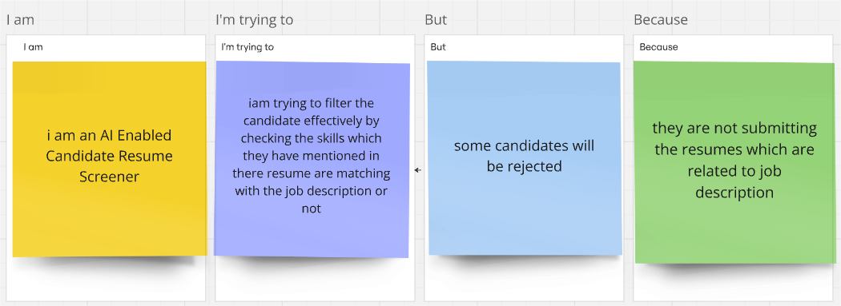

Problem  Statement (PS) | I am  (Customer) | I’m trying to | But | Because | Which makes me feel
PS-1 | Recruiter | Recruite the people who had the skills relavant to the job which I have posted | It is becoming very hard to identify the candidate with proper skills | So many applications had got to me | Very stressful
PS-2 | Job seeker | Get the job | Am applying to so many jobs but am getting the reply very late | Its takes time to verify so many applications manually | Very discouraged

